­Bee Lazi

Software Development Plan (Small Project)

Version 2.0

Revision History

|  |  |  |  |
| --- | --- | --- | --- |
| **Date** | **Version** | **Description** | **Author** |
| 31/10/2016 | 1.0 | Draft Documentation | Gia-An To |
| 15/11/2016 | 2.0 | Adding more details after TA’s feedback | Gia-An To |
|  |  |  |  |
|  |  |  |  |

Table of Contents

1. Introduction 4

2. Project Overview 4

2.1 Project Purpose, Scope, and Objectives 4

2.2 Assumptions and Constraints 4

2.3 Project Deliverables 4

3. Project Organization 4

3.1 Organizational Structure 4

3.2 Roles and Responsibilities 4

4. Management Process 4

4.1 Project Estimates 4

4.2 Project Plan 4

4.2.1 Phase and Iteration Plan 5

4.2.2 Releases 5

4.2.3 Project Schedule 5

4.2.4 Project Resourcing 5

4.3 Project Monitoring and Control 5

4.3.1 Reporting 5

4.3.2 Risk Management 5

4.3.3 Configuration Management 6

Software Development Plan (Small Project)

# Introduction

This document includes detailed project’s plan for our team to stick to, and also make a change, reconsider it throughout the process.

# Project Overview

## Project Purpose, Scope, and Objectives

This project proposes an easy and quick way to help people have more confident in making decisions. A system can be improved through time and provides better suggestions. The product is aimed to lazy and busy people such as the youth, workers, and employees.

## Assumptions and Constraints

* Project has a fixed schedule of 10 weeks
* Zero-budget project
* Project has 5 people, there will be no more people added during the project
* Report the process weekly.
* Complete important feature listed in vision document.

## Project Deliverables

* First draft of Project’s plan and Vision document: 31/10/2016
* Second edition of documents: 1/11/2016.
* Tasks and project’s fields completely separated on Trello: 7/11/2016.
* Data summarization: 8/11/2016.
* Test data: 26/11/2016.
* Demo version of application: 5/12/2016.
* Alpha version of application: 7/12/2016.
* High accuracy suggestions with characteristic.
* Lists of confidential questions.
* Friendly User Interface.
* Proper activity schedule.
* Exciting experience which is suitable for users’ hobbies.

# Project Organization

## Organizational Structure

## Roles and Responsibilities

|  |  |
| --- | --- |
| **Person** | **Role** |
| Tu-Khiem Le, Designer  Quoc-Huu Che, Tester  Manh-Tien Nguyen-Hoang, Van-Tu Ninh, Developer  Gia-An To, Team leader | Design the components, classes, interface.  Write test plan and test cases. Perfom testing.  Write source code, perform unit test, review source code.  Write project plan , monitor and report status, coordinate meetings |

# Management Process

## Project Estimates

10 person-month. Basis for those estimates is the amount of workload for 5 people in approximately 2 months.

## Project Plan

### Phase and Iteration Plan

**_Phase 1: Inception (17/10-30/10)**

+ Iteration 1: Project plan, vision document, weekly report

+ Iteration 2: Detailed vision document, revised project plan, weekly report, initial use case model

**_Phase 2: Elaboration (31/10-20/11)**

+ Iteration 3: Revised project plan, revised vision document, use case document with a revised use case model

+Iteration 4: design document (including UI prototypes, architecture document)

+Iteration 5: Test plan

**_Phase 3: Construction (21/11-18/12)**

+Iteration 6: Revised artifacts submitted in Elaboration.

+Iteration 7: Code and implement main feature.

+Iteration 8: Create test cases, fix defects, and continue to code other feature.

+Iteration 9: Writing test report. Release demo.

**_Phase 4: Transition (19/12-25/12)**

+Iteration 10: Final review. Release alpha version.

### Releases

The software release is a demo on December 5th with main feature are smart activity suggestion (food, entertainment places) with proper time in user’s schedule, attractive and simple UI. With any suggestion, user only answer yes or no to show their agreement to the suggestions. The application uses the answer to analyze and gives more suitable result to user. Alpha version is expected to be released on December 7th after having fixed errors and improved performance.

### Project Schedule

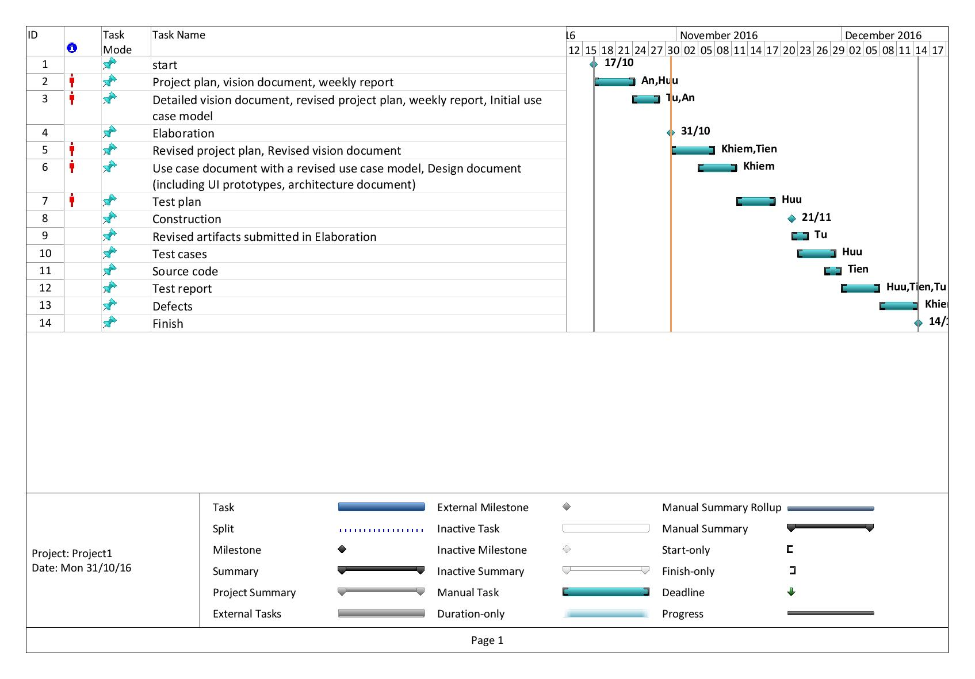

## Project Monitoring and Control

### Reporting

* Weekly meeting ( at 3:30p.m Friday’s evening)
* Weekly status report (Weekly report template)
* Discussing on Slack (https://cs300ctt502fall2016.slack.com/archives/apcs_01)
* Trello card updating (https://trello.com/b/AiOUDlX9/apcs-01)

### Risk Management

|  |  |  |  |  |  |
| --- | --- | --- | --- | --- | --- |
| Risk ID | Risk Description | Probability | Impact | Priority | Mitigation Strategy or Contingency Plan |
| R1 | Low accuracy of suggestion | High | Main feature | Highest | Make the early suggestions more general than later suggestions (after the system has been trained) |
| R2 | Do not have enough time to finish the project | Moderate | Impact on the final product | Moderate | Balance the time and effort consumption on Subjects taken this Semester. |
| R3 | Team member is busy | Moderate | Mostly on parts of the system that they have responsibility for. | Moderate | Team members require to finish their own jobs as soon as possible and before the due date. Arrangement on personal’s work have to be done. |
| R4 | User may not be honest in interaction with the application | Moderate | Huge impact on the results of suggestions | Low | Offer a best solutions based on what they choose, give them a responsibility to be honest in interaction to have correct results. |
| R5 | Underestimate the time to complete tasks | Moderate | Tasks maybe undone and not co-operated well in overall system | Moderate | Balance the workloads reasonably for each team members. |

### Configuration Management

* Google drive or Dropbox for storing and sharing documents and files.
* Git, Bitbucket for managing source code and related files.
* Slack for communicating with team members
* Trello for task assignment